Experiment-18
Aim:
To write a Prolog program to create a database containing names and dates of birth (DOB) and retrieve the details using queries.
Algorithm:
- Start the Prolog program.
- Create database facts using person(Name, DOB).
- Insert the names and corresponding dates of birth into the database.
- Define rules to display all records and search for a person's DOB.
- Load the database file into the Prolog interpreter.
- Execute queries to retrieve the required details.
- Display the results.
- Stop the program.
Code:
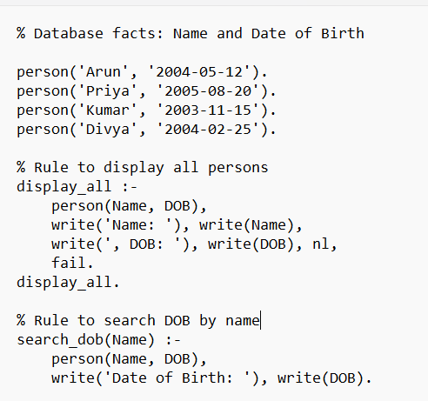
Output:
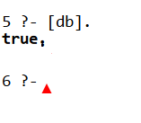
Result:Thus the prolog progam to create a database containing names and dates of birth (DOB) and retrieve the details using queries.

